BCH622:: Helix Worksheet revised January 2020

Hydrogen bonds are crucial to understanding helices, and H-bonds and helices are important to understanding and analyzing both individual structures and data compilations such as Ramachandran plots. Therefore, your first step should be to go through the H-bond Worksheet and HbondPractice.kin at whatever level of detail you need in order to feel comfortable with the definitions and with the practical skill of recognizing the geometry of H-bonds in graphics (or figures) - good or bad or marginal.
Then read the helix section in Anatomy and Taxonomy (IIA), including the green update comments, and use it as background for this worksheet.

1. Classic alpha-helices and helix caps
Open file 2hmqHelixExtras.kin (24KB) (helix B from a hemerythrin subunit) in KiNG.
Confirm for yourself that this helix is righthanded (point & move your right thumb in the direction the COs point, and check that your right-hand fingers can follow the backbone direction around the helical spiral). Is it approximately straight? _____
In the central section (View2) where the H-bonding is regular, choose one helical H-bond: it is from the carbonyl O of residue _____ to the amide H of residue _____ (that is, residues i to i+ _____ ). What is the distance between O and N atoms? _______Å (H atoms are not shown in this kin.) On the Tools menu, turn on Measures, and measure the phi angle value (click C, N, Cα, C atoms) of a good α-helical residue: ______°, then its psi angle (click on one more atom, the next N): ____°. Turn off Measures. List the other 10 backbone atoms (besides the O...H-N) that complete its H-bonded loop, for a total of 13:
Oi _____ _____ _____ _____ _____ _____ _____ _____ _____ _____ Ni+4.

How many total i to i+4 H-bonds are shown for this helix? _____
How many that are NOT i to i+4? ____
To check yourself, turn "Extras" on, then off again. Choose View3 (ca 55, N close), which looks at two turns of helix end-on from the N-terminus, and turn off all list buttons except "mainchain". In the box below, sketch the pattern formed by the backbone in this view.
Turn on the side chains. Show on your sketch some of the Cα-Cβ bonds. Do they extend outradially, spiral clockwise, or spiral counterclockwise? __________________________________

Answer the same question, as viewed from the other end of the helix (View 4)______________________
Turn on labels again, and choose View5 (N end to 55). Locate the Cα of Phe 55; which Cα of
the top turn is most exactly in line with 55 Cα? _____
Subtract those residue numbers: there is an interval of ________ residues in 3 turns, so the
helical pitch is ________ residues per turn.

Turn on H-bonds and N & O atoms again. Is the H-bonding regular in the ﬁrst turn of the
helix? ________ (use View6)
Find the ﬁrst residue that makes one helical H-bond: ________ ________ . It is half-in and
half-out of the helix, with the peptide after its Cα in good helix geometry and the peptide
before it going off in a completely different direction. It is called the helix N-cap residue. Turn
and look at it from all directions, to learn to recognize this important N-cap relationship.
Three backbone N atoms in the ﬁrst turn cannot make helical H-bonds. What atom of what
residue is theoretically in position to H-bond with the N of residue 43? ________ of
________ _____ At what distance? ______ To check yourself, turn "Extras" on, then off
again. As you know, it should really be the sidechain O atom making that H-bond. In this
structure, the N-cap Asn has been incorrectly ﬁt ﬂipped over by 180°; such sidechain amide
ﬂips are not uncommon because the electron density looks nearly identical for an N and an O.

In View8, study the more complex (but classic) relationships at the helix C-cap. Near the helix
end, the H-bonds shift to the i to i+3 pattern of 3-10 helix, starting with a bifurcated H-bond
shared at the NH of ________ _____ . How many 3-10 H-bonds are there? ____ (To check
yourself, turn on Extras, where the 3-10 bonds are colored orange.)

The ﬁnal ﬂinging-outward of the backbone at this C-cap happens at residue Gln 66, surrounded by two H-bonds which join the expected two pairs of atoms but in reverse order, so they are an i+3 and an i+5 rather than two i+4s. (Turn on Extras to see them in orange and red.) Measure the phi angle of Gln 66: _____°, and the psi angle: _____°; those values put it in the _________ region of theRamachandran plot (α, β, or Lα).
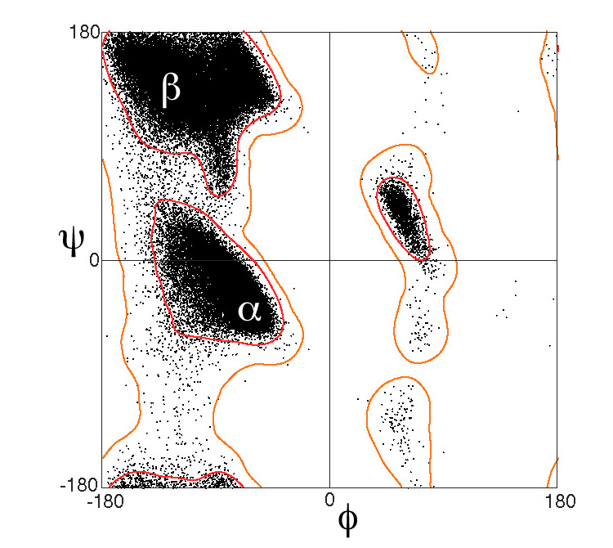

Now study kinemage II.A_hlxCaps.kin from Anatax II.A (download from this website lesson).
Practice recognizing the N and C-cap residues, the characteristic N-cap and cap-box sidechain-backbone H-bonds, the backbone H-bonds of an Lα Gly C-cap, andthe "hydrophobic staple" pairs when present. The N-cap residue of helix 1 is _________ ______, and the N-cap of helix 2 is _________ ______. [Note that the chainID is "4".] The hydrophobic staple of helix 1 is between residues _________ ______ and _________ ______.
The C-cap residue of helix 4 is _________ ______.

2. Helix variants

A. Coiled-coil (supercoiled) helices
2tma.kin (52KB) (tropomyosin)

The two chains are related by an exact twofold parallel to their length. Instead of being fairly short and straight, like typical globular-protein helices, these helices are about _____ turns long and coil around one another. Neighboring pairs stay the same distance apart all along, and the internal packing of hydrophobic side chains repeats approximately in multiples of seven residues.

B. A bent helix
2mlt.a.kin (20KB) (one melittin chain)

This helix has an unusually sharp bend in the middle, of around _____ degrees.
Center on Pro 14, and turn on the side chains. How many helical H-bonds are missing at the
bend? _____
Which peptide has the most distorted configuration? _____
Which CO would have been the H-bond partner of a residue 14 NH? __________
What is the effect of the Pro ring on the above residue and its
backbone? ____________________________
This helix is membrane-active, and has a rather extreme segregation of charges and
hydrophobics. With side chains off but labels on, look down each half of it end-on, and locate
the charged side and the hydrophobic side. Which is toward the inside (concave side) of the
bend? ____________________

C. A 3-10 helix
2cyp.kin (164KB) (cytochrome C peroxidase)

Look at the main chain and the heme and Fe (and H-bonds if you want them), just to get some
feeling for the overall molecule.
Now turn on just the fragment in order to examine residues 164-177, which form a rather
unusual helix buried in the middle of CYP, on one side of the heme. Look end-on from the
N-term; does the shape look familiar? _______________
What is the typical H-bond pattern for the first half of the helix (res. 164-170)? i to i+ ______

Now turn to look end-on from the C-terminal. Sketch the pattern of backbone in box below:

What is the typical H-bond pattern for residues 171-177? _________
Turn on side chains and add Cα-Cβ vectors to your sketch. What is different about 3-10- versus alpha helix that might be of use here in this protein? The N term part is quite classic alpha-helix; it even starts with an Asn, again, which is the commonest side chain in that position, and has 2 negative charges in the first turn (also typical). This is one of the longer pieces of 3-10 helix in the data bank, but it does hold to the usual feature of short 3-10 in occurring at the C-term end of an alpha-helix.
Comparing the alpha half with the 3-10 half, for which one are Cα's in successive turns lined up parallel to the helix axis? ________
For which one are the H-bonds approximately parallel to the helix axis? ________

3. Helices on the Ramachandran plot
Go to the MolProbity site (http://molprobity.biochem.duke.edu) and fetch the 2MLT structure from the PDB. On the main page, choose "Analyze geometry without all-atom contacts" and run with the defaults.Click to view the Ramachandran-plot kinemage. Animate three steps, to the Pro data, where the only points are in the ______ region of the plot; then one more step to the pre-Pro, with points in the _______ region. Animate back to "All data", and click to identify the data point that lies farthest from the main cluster: ________ _____. It is one of the chain termini, so less constrained. The other, to the left of alpha, is ______ A 11, on one side of the helix bend. Use "Edit/Find point" with markers turned on to locate residue B 11. Is its conformation more helix-like? _________ A conclusion, then, is that even as a dramatic bend as this one can be formed with only rather subtle local changes in phi,psi values. Close the Rama window, continue to the main page, and log out of MolProbity.

Open file general-noGPIVpreP_whbkg.kin.gz (9MB) in KiNG. It is a general-case Ramachandran plot from 4400 high-resolution files, yielding over half a million residues with backbone B-factors < 30. View2 zooms in on the "comet" shape in the alpha region. The 3-10 helix in 2CYP has phi,psi values of about -68,-12. Turn on Tools/Show xyz coordinates, and click on datapoints to locate ones near those values. Where do they lie relative to the main alpha cluster? _______________
relative to the "comet" tail? _________________

There is a lot of local detail in such a plot that no one yet fully understands.
In the view3 closeup, pick a datapoint at the center of the most highly populated cluster; its phi,psi values are ______,______. Ideal alpha-helix is often cited as -60,-40, which is not too far away.
The official IUPAC-IUB value (from 1970) is -57,-47;
find where that lies relative to the cluster: ____________________________.

Only one point in 2000 is outside the outer contour, and most of those are close to the allowed regions. Click to identify one of the 3 data points near the middle of an ellipse that outlines a drastically disallowed steric clash: ________ _____ in file _______. One of those cases is a clearly misfit peptide out of density, while the other two are basically a nomenclature problem: an autocatalytic active site modification in related ammonia lyase enzymes that puts a covalent bond between adjacent peptides - these should have been flagged as "het" groups in the PDB file but were not.

